**Fresh Bites Catering**

**Introduction**

Fresh Bites Catering is a full-service catering company committed to delivering exceptional dining experiences. Our commitment to quality, creativity, and customer satisfaction sets us apart in the industry. Here's an overview of what we offer:

Diverse Menus: Our culinary team designs diverse menus that cater to a range of tastes and dietary preferences, ensuring everyone at your event finds something to enjoy.

Fresh Ingredients: We source the finest, freshest ingredients to create dishes that are not only delicious but also visually stunning.

Customization: We work closely with you to customize your catering experience, tailoring the menu to suit your event's theme and your guests' preferences.

Impeccable Service: Our professional staff goes above and beyond to ensure your event runs smoothly, providing top-notch service from start to finish.

Event Variety: Fresh Bites Catering is equipped to handle a wide array of events, from weddings and corporate gatherings to private parties and more.

**Uses**

Corporate Events: Fresh Bites Catering is ideal for corporate meetings, conferences, and seminars, providing a convenient way to offer meals and refreshments to attendees.

Weddings: Many couples use catering services like Fresh Bites for their wedding receptions, ensuring that guests are served delicious food and the couple can focus on their special day.

Private Parties: Whether it’s a birthday, anniversary, or any other celebration, Fresh Bites can handle the catering, allowing hosts to enjoy the event with their guests.

Social Gatherings: Catering can be used for family reunions, holiday parties, and other social gatherings, making it easier to feed a large group of people.

Special Occasions: Fresh Bites can be used for special occasions like graduation parties, baby showers, and more.

Non-Profit Events: Catering services can be used for fundraising events, charity galas, and community gatherings.

School and College Events: Fresh Bites can cater school functions, proms, graduations, and college events.

Sports Events: Catering services are commonly used at sports events, providing a variety of snacks and meals for spectators.

**Empathy**

User Persona: Identify the primary user group, which could be event organizers, and understand their needs and goals when it comes to catering services.

Observations: Gather insights by observing and engaging with potential users, such as event planners or hosts. Understand their pain points and challenges when organizing events that require catering.

Needs and Wants: Determine what the users need and want from Fresh Bites Catering. This could include a diverse menu, flexible pricing, timely delivery, and outstanding customer service.

Thoughts and Feelings: Explore the emotions and thoughts of the users. For example, they might feel stressed about coordinating catering for an event or want to impress their guests with exceptional food.

Quotes and Verbatims: Collect direct quotes and feedback from users about their experiences and expectations regarding catering services. This can provide valuable insights into their specific requirements.

Pains: Identify the obstacles and challenges that users face when dealing with catering services, such as budget constraints, limited menu options, or unreliable vendors.

Gains: Understand what users hope to achieve or gain from using Fresh Bites Catering. This might include a seamless catering experience, positive feedback from guests, or cost-effective solutions.

User Journey: Map out the user’s journey from the initial event planning stage to the completion of the event. Identify touchpoints where Fresh Bites Catering can make a positive impact.

By creating an empathy map, Fresh Bites Catering can gain a deeper understanding of their customers’ needs, emotions, and pain points, which will help them tailor their services to provide a more customer-centric and satisfying catering experience.

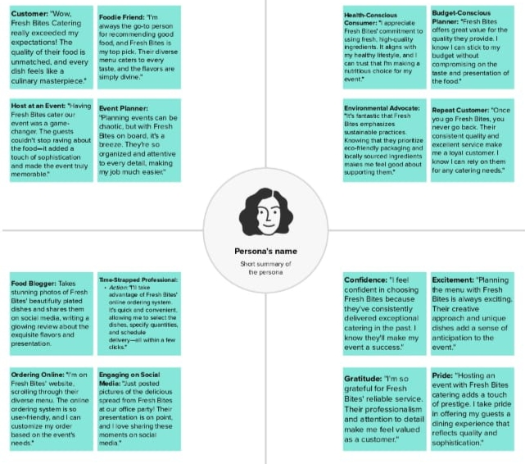

**Brainstorm and idea prioritisation**

Empathize: Understand the needs and preferences of your target customers. Conduct surveys, interviews, or observe their behaviors to gather insights.

Define: Clearly define the catering challenges or opportunities you want to address. For Fresh Bites, this could be enhancing menu options or improving service efficiency.

Ideate: Encourage a diverse group of team members to brainstorm ideas without judgment. Think about new menu items, innovative presentation, or ways to streamline catering operations.

Prototype: Create small-scale models or trials of your ideas. Test new recipes, experiment with different plating styles, or implement process changes on a limited scale.

Test: Collect feedback from customers and stakeholders through tasting sessions or surveys. Learn from the prototype phase and refine your concepts accordingly.

Implement: Roll out the successful ideas to improve the catering service. Continuously gather feedback and make necessary adjustments to maintain freshness and quality.

Design thinking in the context of catering can lead to creative menu offerings, efficient processes, and a more satisfying experience for clients and guests.

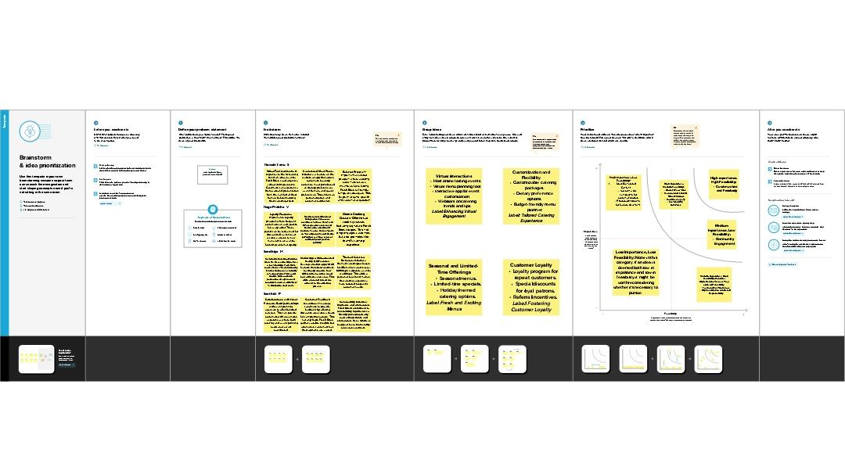

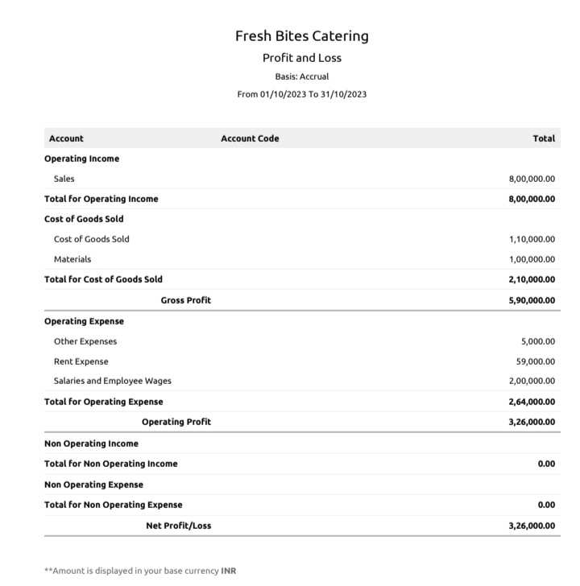**Result**

**Advantages**

Quality Food: Fresh Bites Catering focuses on providing high-quality, fresh, and well-prepared food for events and gatherings.

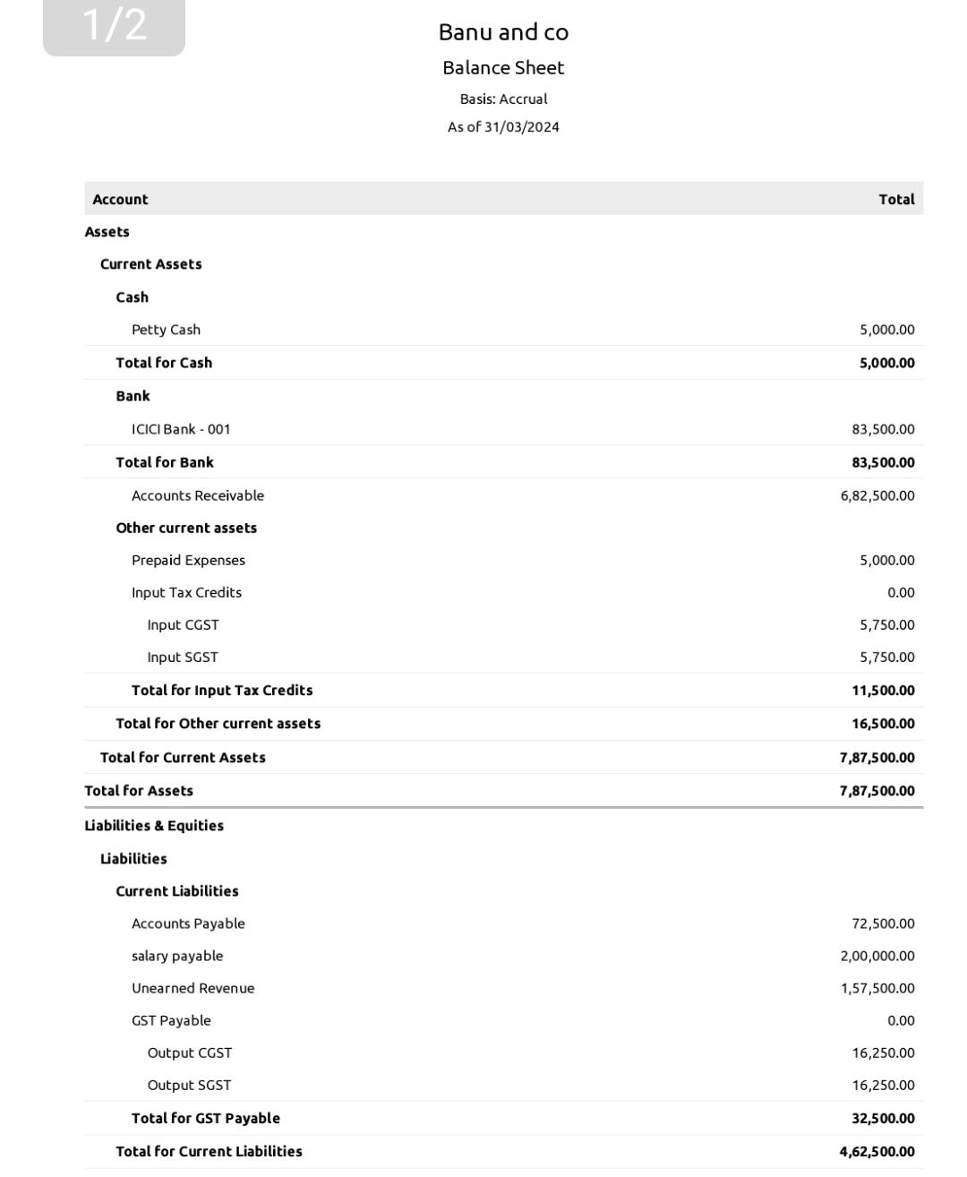Diverse Menu: They often offer a diverse menu with a variety of options to cater to different tastes and dietary preferences.

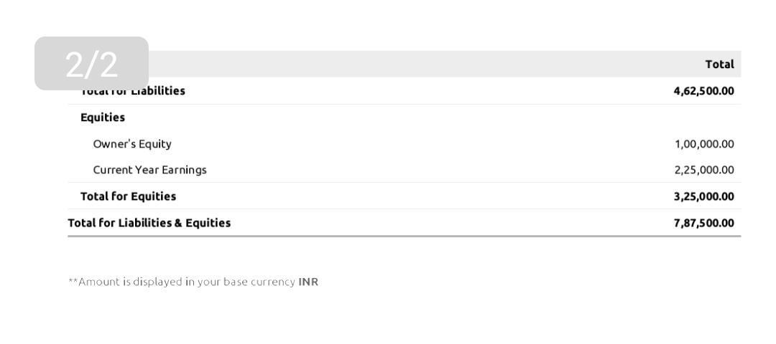Convenience: Catering services like Fresh Bites save you the time and effort of cooking and serving food for your event.

Professional Presentation: Caterers are skilled in presenting food attractively, enhancing the overall dining experience.

Customization: Many catering services can customize menus and services to meet the specific needs of your event.

Expertise: Catering staff are trained to handle various aspects of food service, ensuring a smooth and professional event.

Efficiency: They can efficiently serve a large number of guests, making them suitable for events of all sizes.

Stress Reduction: Using a catering service can reduce the stress associated with planning and preparing food for an event.

Time-Saving: It frees you up to focus on other aspects of your event, such as hosting and entertainment.

Variety: Fresh Bites Catering can often provide a range of cuisine types, from traditional to exotic, to suit the theme of your event.

These advantages can make Fresh Bites Catering or a similar service a practical choice for various occasions and events.

**Disadvantages**

Cost: Catering services can be relatively expensive, especially for high-quality or specialized menus.

Limited Menu Choices: Some catering services may have a limited menu selection, which could restrict your options for customization.

Dietary Restrictions: It can be challenging to accommodate specific dietary restrictions or preferences, such as vegan, gluten-free, or allergen-free diets, for a large group.

Coordination: Coordinating with a catering service requires planning and communication, which can be time-consuming.

Reliance on External Services: You depend on an external vendor for an essential part of your event, which can introduce an element of risk.

Hidden Costs: Be mindful of potential hidden costs, such as service charges, delivery fees, or equipment rentals.

Scheduling: Timing and scheduling can be critical to ensure that the food is ready and served on time.

Limited Control: You may have less control over the preparation and presentation of the food compared to cooking it yourself.

Leftovers: You might have excess food, which can lead to waste or storage challenges.

Quality Variability: The quality of the catering service can vary, so it’s essential to research and choose a reputable provider.

**Application**

Corporate Events: Provide catering services for business meetings, conferences, and office lunches.

Weddings: Offer wedding catering services to make the special day memorable.

Social Gatherings: Cater to birthday parties, anniversaries, and other private events.

Healthcare Facilities: Provide healthy and nutritious meal options for hospitals, clinics, and nursing homes.

Schools and Universities: Offer catering for school events, graduation ceremonies, and campus functions.

Sports Events: Cater to sports tournaments, games, and related events.

Non-profit and Charity Events: Support fundraisers, galas, and charitable functions.

Government and Military Events: Serve catering for government meetings, military ceremonies, and official events.

Cultural and Religious Events: Cater to cultural festivals, religious ceremonies, and community gatherings.

Film and Entertainment Industry: Provide catering for film sets, studios, and events in the entertainment industry.

Outdoor and Adventure Activities: Offer catering for camping trips, outdoor excursions, and adventure events.

Airport Lounges: Serve passengers and travelers in airport lounges with a variety of food options.

Food Trucks and Festivals: Participate in food truck events and food festivals.

Home Meal Delivery: Offer meal delivery services to individuals and families.

Virtual Events: Provide virtual catering options for online meetings and conferences.

**Future Scope**

Sustainability Initiatives: As environmental concerns continue to rise, Fresh Bites Catering can explore sustainable catering practices, such as sourcing local and organic ingredients, reducing food waste, and adopting eco-friendly packaging.

Online Ordering and Delivery: Expanding online ordering and delivery services can tap into the growing demand for convenient and contactless food services, especially in the post-pandemic world.

Dietary Preferences: Catering to diverse dietary preferences, including vegetarian, vegan, gluten-free, and other specialty diets, can attract a broader customer base.

Food Truck Expansion: Expanding into the food truck industry and participating in food festivals and events can provide new revenue streams and increased brand visibility.

Virtual Catering: Offering virtual catering packages for online meetings, conferences, and remote events can cater to the evolving needs of the digital age.

Partnerships and Collaborations: Collaborating with event planners, wedding venues, and other businesses can create mutually beneficial partnerships and extend the reach of Fresh Bites Catering.

International Expansion: Exploring opportunities to expand into new geographic regions or countries can open up a larger market for the business.

Specialized Services: Diversifying into specialized catering niches, such as gourmet cuisine, themed events, or high-end corporate functions, can attract clients seeking unique and exclusive catering experiences.

Technology Integration: Incorporating technology solutions like mobile apps for easy ordering and tracking, as well as data analytics for customer insights, can enhance the customer experience.

Community Engagement: Engaging with the local community through charity events, food donations, and involvement in social causes can foster a positive brand image.